**DBMS LAB**

**ASSIGNMENT-11**

**SNEHA SINGH**

**20198023**

**IT 5 B2**

**1. Write a row trigger that copies the rows of 'Salary' table in a new table 'Salary_new' which has same schema. The trigger executes in case of updation of 'Salary' table.**

create table salary(Emp_No number,Basic number,HRA number,DA number,Total_Dedution number,Net_Salary number,Gross_Salary number);

insert into salary values(2,15000,4000,1000,5000,15000,20000);

insert into salary values(1,31000,8000,1000,5000,35000,40000);

insert into salary values(3,14000,4000,1000,5000,15000,19000);

insert into salary values(4,14000,4000,1000,5000,15000,19000);

insert into salary values(5,13000,4000,1000,5000,15000,18000);

create table salary_new(Emp_no number,Basic number,HRA number,DA number,Total_Dedution number,Net_Salary number,Gross_Salary number);

create or replace trigger salary_change before update on salary

for each row

begin

insert into salary_new values(:OLD.Emp_no, :OLD.Basic, :OLD.HRA, :OLD.DA , :OLD.Total_Dedution, :OLD.Net_Salary, :OLD.Gross_Salary);

end;

/

update Salary set basic = 20000 where Emp_no=2;

select * from salary;

select * from salary_new;

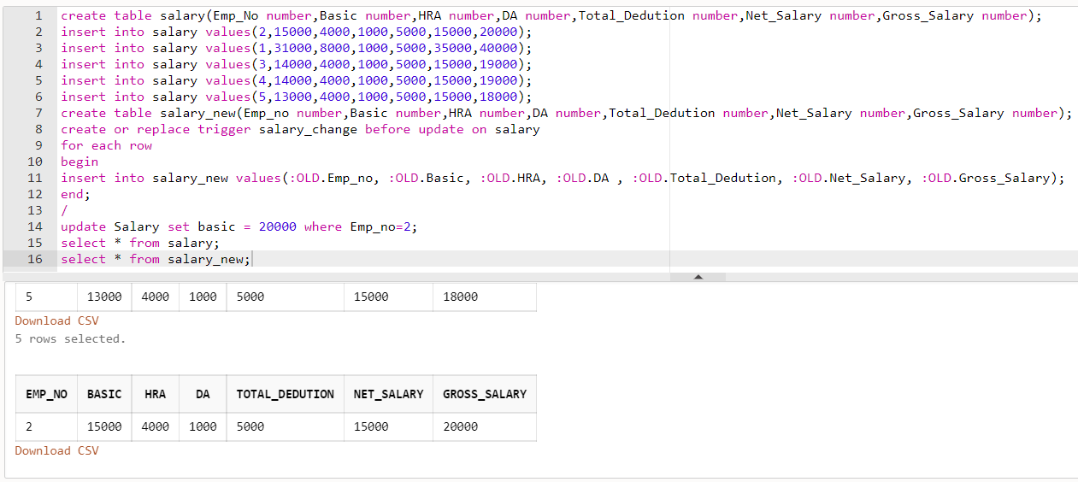

**2. A Factory maintains records of Stock-On-Hand and material requirements in the Item_Master table and Item_Requisite table respectively. Write the code for trigger, which on deletion of any row in Item_Requisite, updates the Bal_Stock in the Item_Master table for that requisite. If the value in Bal_Stock becomes negative, the update operation should not be allowed.**

create table item_master(item_id number,description varchar(20),bal_stock number);

create table item_requisite(item_id number,dept_code varchar(20),quantity number);

insert into item_master values(101,'keyboard',80);

insert into item_master values(102,'lathe_machine',70);

insert into item_master values(103,'compass',100);

insert into item_master values(104,'beaker',90);

insert into item_master values(105,'ammeter',60);

insert into item_requisite values(101,'keyboard',30);

insert into item_requisite values(102,'mech',20);

insert into item_requisite values(103,'civil',25);

insert into item_requisite values(104,'chem',35);

insert into item_requisite values(105,'elect',80);

create or replace trigger change_requisite before delete on item_requisite

for each row

DECLARE

txt EXCEPTION;

bal_stock number;

begin

select bal_stock into bal_stock from item_master where item_id=:OLD.item_id;

if(:old.quantity > bal_stock)

then

RAISE_APPLICATION_ERROR(-20000,'Invalid operation');

else

update item_master set bal_stock = bal_stock - :OLD.quantity where item_id = :OLD.item_id;

end if;

end;

/

delete from item_requisite where item_id=104;

select * from item_master;

select * from item_requisite;

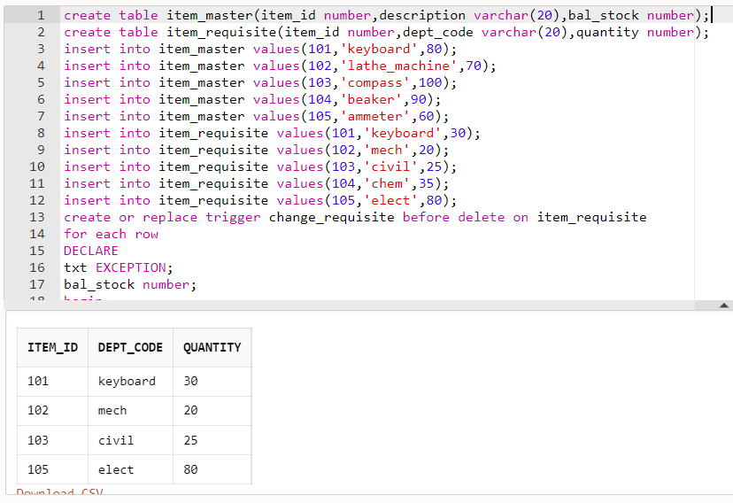

**3. An HR system has an 'emp' table that holds a row for each employee in the company. Each record in the table has a manager field that holds name of the employee's manager. Write a trigger so that when a manager’s record is deleted from the emp table, the mgr field of the employees working under that manager is set to NULL.**

create table emp(emp_id number,emp_name varchar(20),mgr varchar(20));

insert into emp values(1001,'Anna',Null);

insert into emp values(1002,'Anthony','Anna');

insert into emp values(1003,'Andy','Sachin');

insert into emp values(1004,'Sam','Anna');

insert into emp values(1005,'Tom','Sam');

insert into emp values(1006,'Ricky','Sam');

insert into emp values(1007,'Sachin','Anna');

insert into emp values(1008,'Amy','Anthony');

insert into emp values(1009,'Cristina','Anna');

insert into emp values(1010,'Jennifer','Anthony');

create or replace trigger deleted_emp before delete on emp

for each row

begin

update emp set mgr=null where mgr=:OLD.mgr;

end;

/

select * from emp;

